
LESSON NOTE | DETAILED EXPLANATORY NOTES
BIOINFORMATICS
DNA SEQUENCING (SANGER & NGS)
GRADE 12 - BIOLOGY
■ ■ ■

What is Bioinformatics?
Bioinformatics is the field that uses computing and data science to store, read and analyze biological information - especially the sequences of DNA, RNA and proteins. One of its foundations is DNA sequencing: working out the exact order of the bases in a piece of DNA. Once a sequence is known, computers can compare it, search it for genes, and use it in medicine, agriculture and research.
This lesson looks at how DNA is sequenced - the classic Sanger method and modern Next-Generation Sequencing (NGS) - and how short pieces of sequence are pieced together into whole genomes.
What DNA Sequencing is Used For
- Determine the code of a particular gene or whole organism.
- Identify mutations - e.g. drug resistance in a pathogen (such as HIV) or inherited diseases.
- Characterize variants (polymorphisms) and haplotypes of genes.
- Type bacteria, viruses and pathogens, and map routes of transmission (molecular epidemiology).
DNA Sequencing (Sanger & NGS)
Key Learning Outcomes
By the end of this lesson, students should be able to:
- Define DNA sequencing and explain why it is important.
- Describe how Sanger sequencing (the chain-termination method) works.
- Explain the role of dNTPs and ddNTPs in Sanger sequencing.
- Describe shotgun sequencing and sequence assembly for whole genomes.
- Describe Next-Generation Sequencing (NGS) and compare it with Sanger sequencing.
What is DNA Sequencing?
DNA sequencing is the operation of determining the precise order of the nucleotide bases - adenine (A), guanine (G), cytosine (C) and thymine (T) - in a strand of DNA. It can be used to read the sequence of individual genes, whole chromosomes, or an entire genome, and it has become the most efficient way to study RNA and proteins as well. Knowing the exact order of the bases is the starting point for almost all of modern genetics and biotechnology.
History: Frederick Sanger
The foundations were laid by the British biochemist Frederick Sanger. In 1955 he completed the sequence of all the amino acids in insulin, showing that proteins have a specific, ordered pattern. Later, in 1977, Sanger and his colleagues developed Sanger sequencing for DNA, which remained the most widely used method for about 40 years and was central to the Human Genome Project.
Sanger Sequencing (Chain Termination)
Sanger sequencing, also called the chain-termination method, determines the order of bases in a piece of DNA (usually less than 1,000 base pairs). With 99.99% accuracy it is considered the “gold standard”, and is still used to verify sequences produced by newer methods. Its clever trick is to stop DNA synthesis at every possible position and then sort the fragments by size.
The reaction uses a primer, DNA polymerase, the four normal dNTPs (A, G, C, T) and a small amount of special ddNTPs (dideoxynucleotides), each tagged with a different fluorescent dye. A ddNTP lacks the 3′–OH group, so once it is added the chain cannot be extended any further and stops.
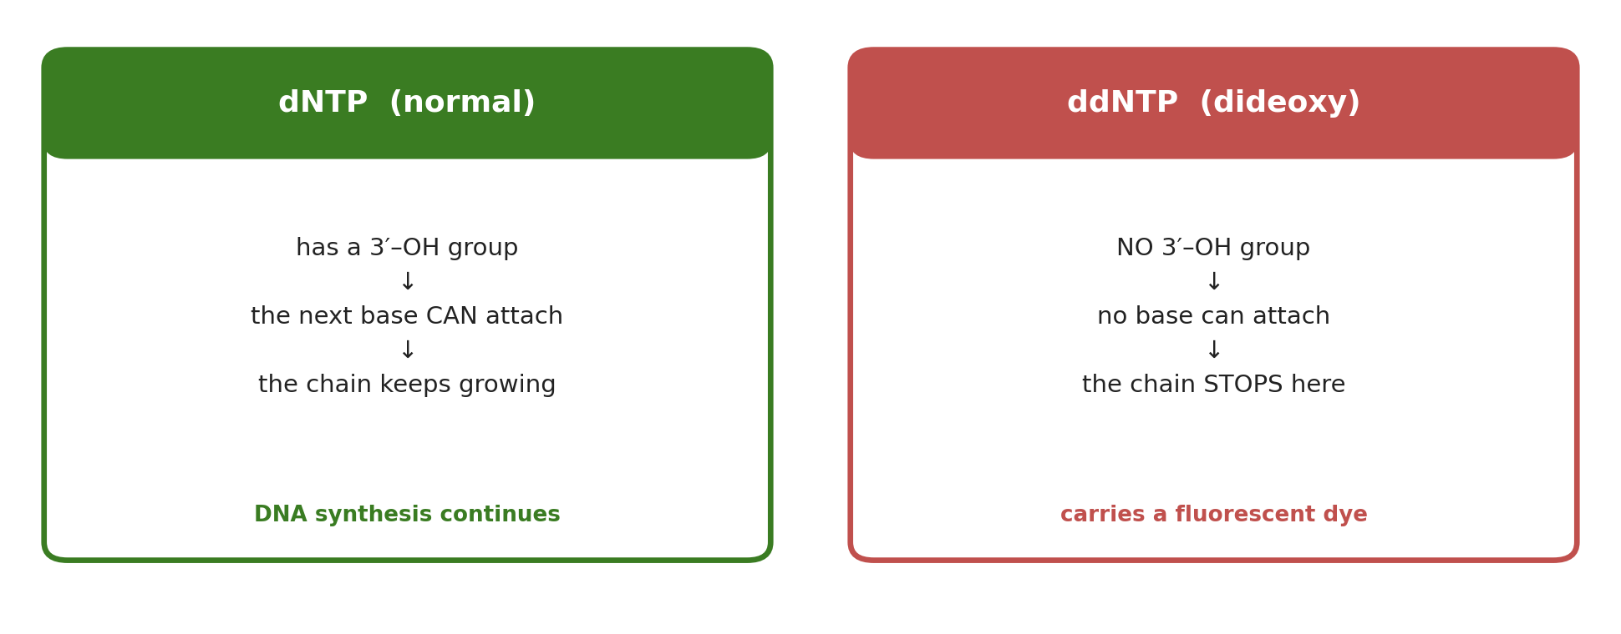
Figure 1: A normal dNTP lets the chain grow; a ddNTP has no 3′–OH group, so it terminates the chain.
Because a ddNTP is added at random positions, the reaction produces DNA fragments of every possible length, each ending in a known, dye-labelled base. Separating these fragments by size using gel electrophoresis - the shorter ones travel further - lets the sequence be read off directly.
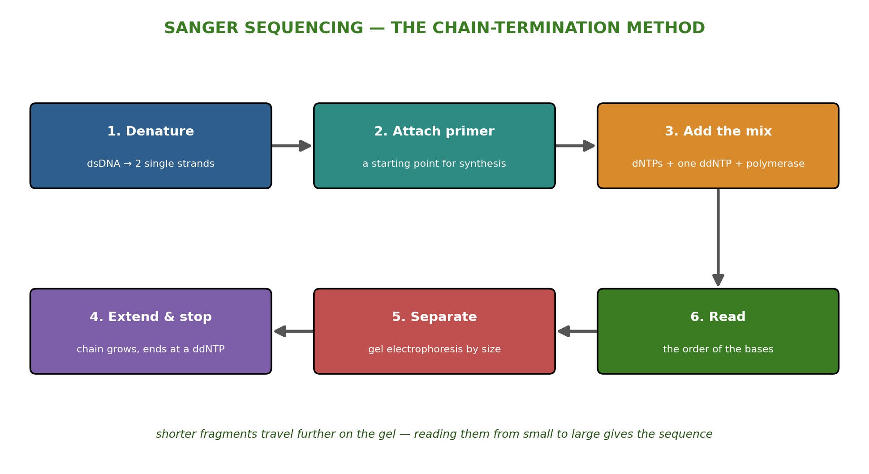
Figure 2: The Sanger (chain-termination) method - fragments of every length are sorted by size to read the sequence.
The Sanger Method in Six Steps
- The double-stranded DNA (dsDNA) is denatured into two single strands (ssDNA).
- A primer matching one end of the sequence is attached.
- Polymerase, dNTPs and one type of ddNTP are added.
- DNA synthesis begins and the chain extends until a ddNTP is randomly incorporated and stops it.
- The resulting fragments are separated into single strands.
- The fragments are separated by gel electrophoresis and the sequence is read.
Whole Genome Sequencing and Shotgun Assembly
A single sequencing reaction only reads a few hundred bases, yet genes are thousands of bases long (the largest human gene, for Duchenne muscular dystrophy, is about 2.4 million bases). To sequence something this large, scientists use shotgun sequencing: the long DNA is broken into many short random pieces called reads (from about 20 up to 30,000 bases). Special software finds where the reads overlap and joins them into longer continuous stretches called contigs, eventually rebuilding the whole sequence - a process called sequence assembly.
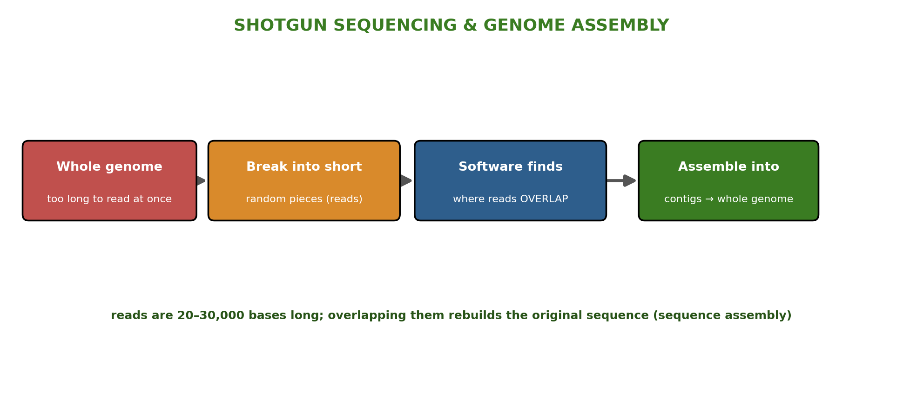
Figure 3: Shotgun sequencing - a genome is broken into overlapping reads that software assembles back into the full sequence.
Assembly is difficult because genomes contain repeated sequences and occasional errors - like trying to reassemble a book that has been shredded, with some repeated paragraphs and a few typos.
Next-Generation Sequencing (NGS)
Next-Generation Sequencing (NGS), also called high-throughput sequencing, is the collective name for many modern technologies - such as Illumina (Solexa), Roche 454, Ion Torrent and Solid. Instead of reading one fragment at a time, NGS sequences millions of fragments in parallel, so it can read many genes - or a whole genome - much faster and more cheaply than Sanger sequencing. This has revolutionized genomics and made large projects, and even personalized genome information, possible.
Feature | Sanger sequencing | Next-Generation Sequencing (NGS)
How it reads | One DNA fragment at a time | Millions of fragments at once (parallel)
Length | Short pieces (< ~1,000 bp) | Short reads assembled into whole genomes
Accuracy | 99.99% - the “gold standard” | Very high, with huge output
Speed & cost | Slower; cost-effective for single genes | Very fast and low cost per base
Best for | Single genes; verifying sequences | Whole genomes and large-scale projects

Applications of DNA Sequencing
DNA sequencing is now an essential tool across biology and medicine:
- Molecular biology - reading genes and studying how they work.
- Evolutionary biology - comparing species to trace common ancestry.
- Virology & medicine - identifying pathogens, drug resistance and inherited diseases.
- Forensic investigation - DNA profiling and identification.
Worked Example - Reading a Sanger Gel
Suppose the fluorescently-labelled fragments, sorted from shortest to longest, end in the bases: G, A, T, C, C, A.
The shortest fragment travelled furthest and ends in G - so the first base is G.
The next fragment (one base longer) ends in A, then T, then C, C, A.
Reading from small to large gives the sequence: 5′ – G A T C C A – 3′.
Each colored band on the gel corresponds to one base, so the order of the bands is the DNA sequence.
Why This Matters
- Foundation of genomics - sequencing turns DNA into readable, comparable data.
- Medicine - it detects mutations, drug resistance and inherited disease, enabling personalized treatment.
- Public health - sequencing pathogens tracks outbreaks and guides responses.
- Bioinformatics - the huge amount of sequence data must be stored and analyzed by computers.
PNG Context Example
DNA sequencing supports research and healthcare across Papua New Guinea - identifying and tracking pathogens such as those causing malaria, tuberculosis and HIV, studying the country's rich biodiversity, and improving crop and livestock varieties. As sequencing becomes cheaper, these tools are increasingly within reach of national laboratories and universities, linking school biology to real scientific work.
References & Related Documents
Source Documents
- STEM Biology Student Resource Book - Grade 12, Term 1. Module 12.1 Bioinformatics, Topic 2: DNA Sequencing (What is DNA Sequencing? History; Sanger Sequencing; Whole Genome & Shotgun Sequencing; Next-Generation Sequencing). Department of Education, PNG (2021).
- STEM Biology Syllabus - Grade 12, Term 1. Thema: Biotechnology; Module 12.1 Bioinformatics, Topic 2: DNA Sequencing.
- Biology Standards-Based Syllabus, Grades 11 & 12 (PNG SBC 2020) - Strand 2: Life; investigate the structural properties of DNA and the role of DNA in heredity and protein synthesis.
Further Reading & References
- Adams, J. (2008). DNA sequencing technologies. Nature Education 1(1):193. https://www.nature.com/scitable
- OpenStax Biology - Whole-Genome Sequencing. https://openstax.org/books/biology

